**.Net Technologies Using C# PROG32356 Assignment 2**

1. Fetch first 10 products

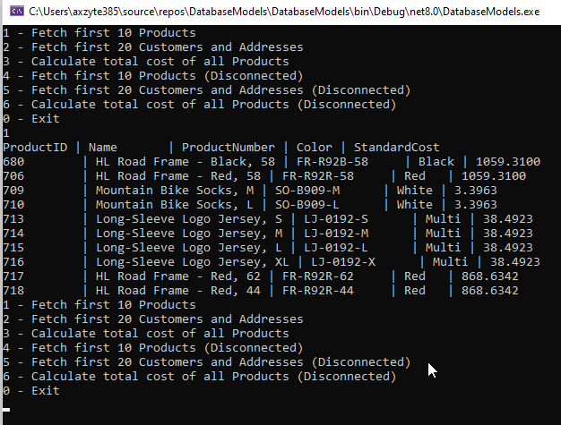

1. Fetch first 20 Customers and Addresses

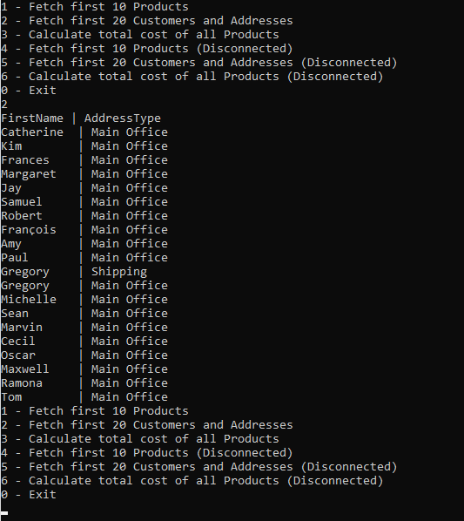

1. Calculate total cost of all Products

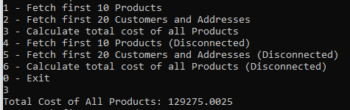

1. Fetch first 10 Products (Disconnected)

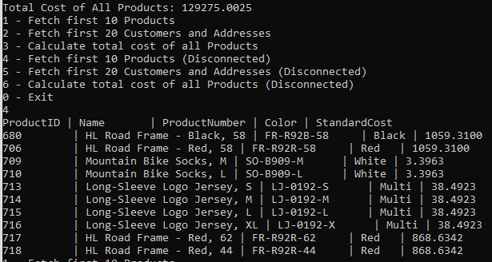

1. Fetch first 20 Customers and Addresses (Disconnected)

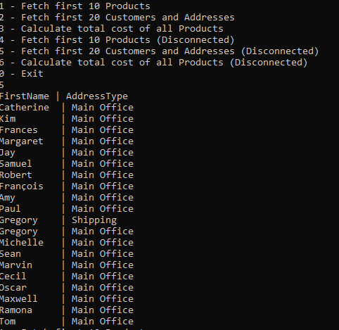

1. Calculate total cost of all Products (Disconnected)

